HOW TO GO TO AKI’s VETERINARY and GROOMING SERVICES
L2 B3 Bonifacio St. Mayumi St/Salcedo Village Sta Rita Olongapo City
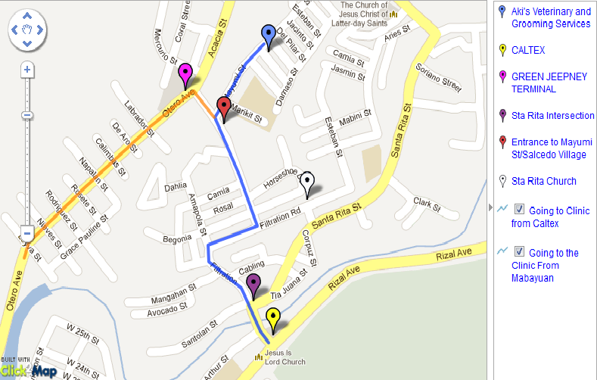
Notes:
- Mayumi St. (now Salcedo Village) ENTRANCE Arch has a SIGNAGE. The entrance is few steps away from FILTRATION BRIDGE (if you are going to MABAYUAN/GORDON HEIGHTS areas).
- Mayumi St. used to be the location of HOLY INFANT JESUS COLLEGE.
- YELLOW Jeepneys have TWO routes. STA. RITA and PEPSI. Make sure you board the PEPSI one. (BLUE LINE route)
- BONIFACIO St. is 2 blocks away from a Mayumi St MINI intersection. Just walk straight ahead.
- There are PEDICABS available around 6am-7pm near Mayumi St. entrance. (6-10pesos per ride)
- The clinic is ADJACENT to a SARI-SARI STORE of a PINK two-storey house. It has a SIGNAGE on top and TARPAULINS in front.

via COMMUTE
- ANY TRICYCLE – State the address (or even just MAYUMI STA RITA) then just check out the landmarks.
- YELLOW Jeepney – Board PEPSI jeepney. Alight on Mayumi St. Entrance. Walk or ride the pedicab going to clinic.
- RED/GREEN Jeepney – Board jeepney going to Gordon Heights area. Alight on Green Jeepney Terminal. Walk through the FILTRATION Bridge until you reach the entrance of Mayumi St. Walk or ride the pedicab after.
via DRIVE – Just follow the map
*please make sure that you scheduled an appointment beforehand.
**you can also ask the store owner for queries.

